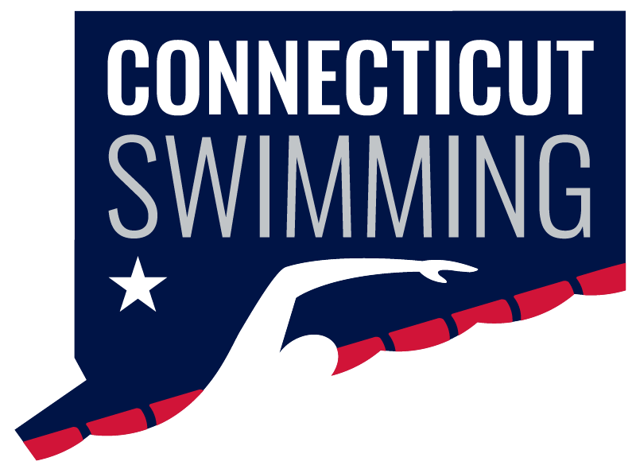
CT Swim Athlete Committee
Aug 6th at 8:00p
Meeting ID: 936 0270 9399
Passcode: 806298

Minutes
Attendance:
- Present: Bri Laforest, Ilse Fedoronko, Luke Scheinfeldt, Maryn Brooks, Matthew Ackerman, Niya Villanueva, Olivia Edwards
- Absent: Greg Pinchbeck, Maya Kruezer, Kylee Grey, and Shayla Knolker
Senior Championships
- Discussed expanding the senior recognition program, including potentially limiting college swimmers at the meets who don't attend many CT meets throughout the year
  - We need to talk to program development about that
- Agreed that senior recognition should be publicized earlier, including announcing names ahead of time.
- Decided that having a DJ/announcer is not a priority (would be nice), and that funds could be better used toward other aspects of senior recognition.
- Other ideas included providing water jugs at meets and having 5-minute breaks after every gender instead of 10 minutes after the girls
Age Group Recap
- We currently have six athlete interviews to work with.
- Discussed adding more spirited activities, including a cheer competition and meet themes.
  - We need to brainstorm potential prizes/incentives
Travel Meet Recognition
- This year, we created a post featuring pictures from travel meets.
- For future years, we discussed encouraging athletes to submit videos and interviews, as well as tagging/DMing other LSC's to gain more traction
Awards Activity
- We outlined what we should put in when applying for each award
Annual Banquet
- The banquet will be Sunday, November 1 at 1:00 PM at the Aqua Turf.
- Scholar-athlete recognition will be included.
- We will be holding a food drive and should begin advertising beforehand and make sure coaches are aware.
- Athlete Committee members should plan to arrive after 10:00 AM to help with setup and volunteering.
Swimposium
- Discussed possible activities and different ways to structure the Swimposium.
- One idea is to have monthly Zoom meetings, followed by an in-person event after the banquet with Zach.
- We also discussed getting more feedback directly from athletes through Zoom and having the Athlete Committee collect feedback every few months.
Upcoming Meetings
- BOD Meeting: August 18 at 8:00 PM
- Athlete Committee Meeting: September 11 at 8:00 PM (tentative)

