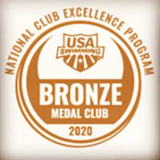

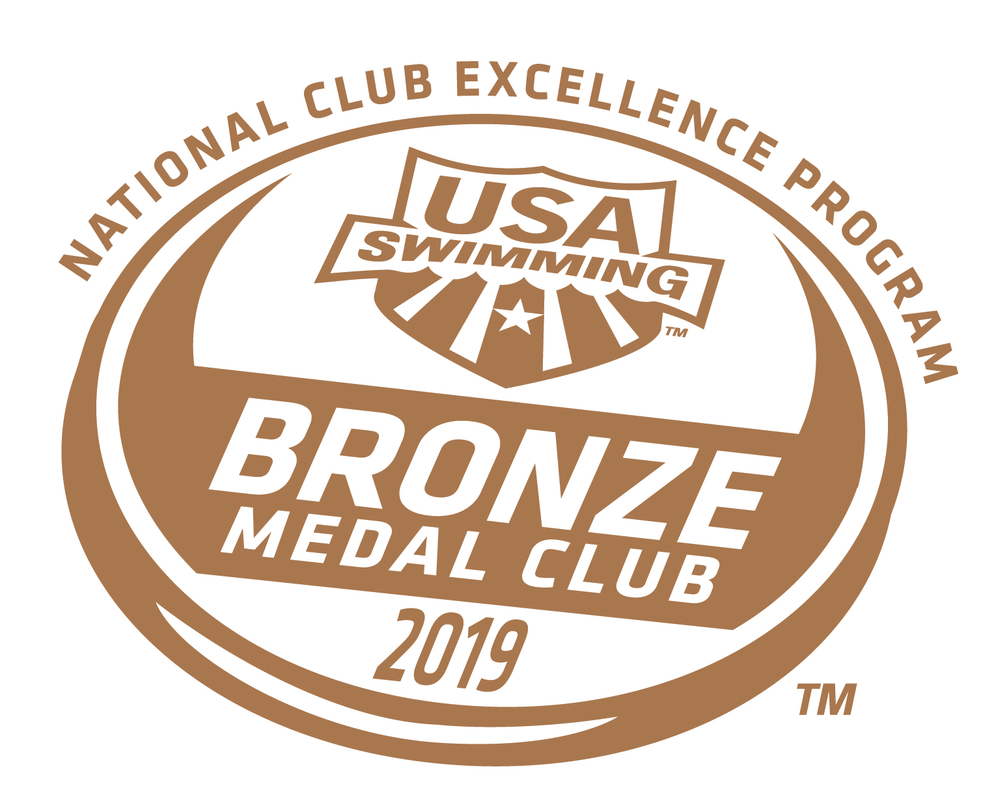

WHAT Swimming is currently accepting applications for an Assistant Age Group Coach.

WHAT Swimming is a coach owned team, a member of International Swim Coaches Association, USA Swimming and an all year round program that trains at the University of Saint Joseph in West Hartford, and Miss Porter’s School in Farmington.

The philosophy of WHAT is simple: “Success is in the Details”.

The WHAT organization is locally and nationally known for their attention to stroke technique, developing and training athletes from an Age Group to National level. The WHAT Organization is looking for innovative and progressive thinking coaches which enhance the overall program and individual performance of all the WHAT athletes.

WHAT is a year-round athletic program that offers opportunities for swimmers of all levels - from the 8-year-old beginner to the 18-year-old Olympic Trials Qualifier.

WHAT is a nationally recognized athletic club with 150 USA Swimming registered swimmers and is one of the highest performing swim clubs in the country.

Recognized among the top 5% of all swim clubs across the United States, WHAT has earned the Bronze Medal ranking by the [USA Swimming Club Excellence Program](https://www.usaswimming.org/coaches-leaders/team-leaders/programs-services/club-excellence) in 2019, 2020 and 2021.

*WHAT Swimming is a comprehensive program that focuses on training the whole athlete and includes:*

* Nutritional education
* Goal-setting techniques
* Strong mental preparation for training and racing
* Injury prevention exercise regimes
* Strength & conditioning routines
* Strong emphasis on technical proficiency in the water

**Responsibilities of Assistant Age Group Coach:**

* 2-3 days per week between the hours of 6:30pm-8:30pm
* Enjoy working with swimmers from 8-12 years of age
* Promotes and encourages a positive, inclusive, supportive, and winning culture
* Serves as coaching point of contact for athletes, their parents and the aquatic facilities we utilize
* Passion for swimming and demonstrates a sound technical understanding of all strokes
* Reports to the Head Coach and collaborates closely to establish a successful competitive team
* Dedicated to developing and growing our high performance standards by cultivating well-rounded excellence in all athletes
* Provides a safe environment for athletes, parents, volunteers, and guests at practices, team events, and meets

**Qualifications:**

* Hold current certifications or willing to obtain certifications for:
  + CPR for the Professional Rescuer/First AID/AED
  + Lifeguard Training/Safety Training for Swim Coaches
  + USA Swimming Foundations of Coaching
  + Athlete Protection Training
* Must successfully complete and pass USA Swimming Background check
* Strong administrative, organizational and computer skills preferred

**Additional benefits:**

* Paid travel and board for meets
* Competitive salary will commensurate with experience
* Yearly budget allocated towards continued coaching education

Interested candidates should submit their resume to Rob Riccobon (Owner/Head Coach/Team Administrator) at [whatcoaches@gmail.com](mailto:whatswim@gmail.com) and should call **860-985-2818** with any questions.