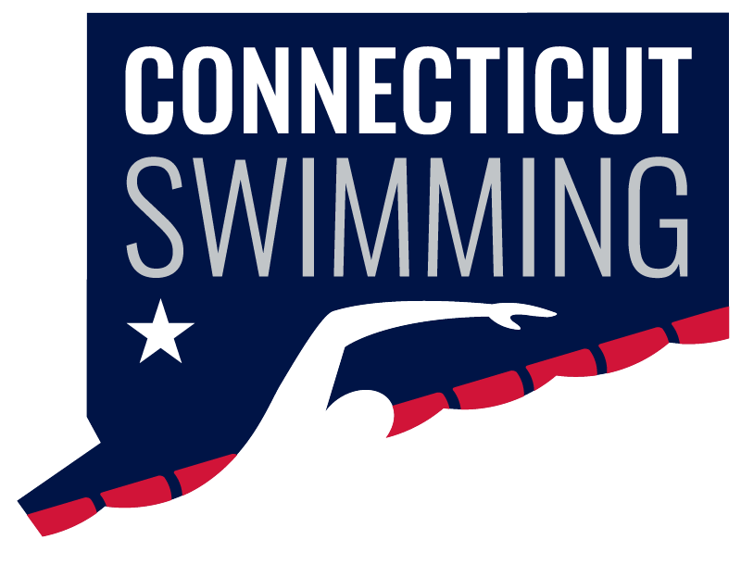
CONNECTICUT SWIMMING
House of Delegates
May 20, 2025, 8:00 PM
Via Zoom
(check your FAST acct for Zoom info)
AGENDA

Vision Statement: Connecticut Swimming…better life through swimming.
Mission Statement: Connecticut Swimming promotes the pursuit of excellence in swimming and in life through competition and education.

Call to Order
Roll Call
Approval of Agenda
Adoption of Minutes – Fall HOD

Final Roll Call for Missing delegates

Old Business

New Business
- 2025 Elections
- Motion to approve the revised Connecticut Swimming by-law document that reflects an organization restructure and the reduction of voting Board members effective May 21, 2025
- Approval of 2025 – 2026 Budget

Reports of Officers, Committee Chairs, and Coordinators
- General Chair Report – Jeff Sargent
- Administrative Vice-Chair – Greg Pinchbeck
- Finance Vice-Chair – Vacant
- Program Development Vice-Chair – Jason Paige
- Program Operations Vice-Chair – Jim Robison
- Athlete Representatives – Samantha Haley, Caroline Ward
- Treasurer – Susan Lecza
- Safe Sport Coordinator – Jeremy Virgil
- Diversity, Equity & Inclusion – Dennis Flores, Emmanuel Lanzo
- Senior Committee Chair – Adriana Schack
- Age Group Committee Chair – Ronnie Vaughan
- Coach Representatives –Sarah Basile, Steven Cusano and Robert Adams-Michaud
- Coach-at-Large – Kristen Finnegan
- Officials Chair – Dylan Lee/Margy Sargent
- Open Water Coordinator – Vacant
- Adapted Swimming - Vacant
- Operational Risk Coordinator – Brandon Foster
- Registration/Membership Coordinator – Kathleen/Davide Mendonca
- Zone Team Coordinator – Seana Bedard

Discussion/Public Comment

Adjournment

