JOB DESCRIPTION 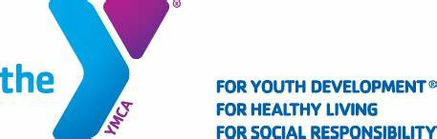
POSITION TITLE: Swim Coach Meriden, New Britain, Berlin YMCA
REPORTS TO: Head Swim Coach
CLASSIFICATION: Full Time with Benefits
SALARY RANGE: $19 plus depending on experience
HOURS: Hours will vary but will include the following practice times
Monday – Thursdays 5:15-8:45 pm
Fridays 4:15-6:45
Weekends for swim meets
General Function:
Under the direction of the Head Swim Coach, you will be responsible for assisting the management and operation of the MNBBY Seals Swim Team. You will follow and enforce safety standards as well as policies and procedures. Duties as assigned to you.
Principal Activities:
- Work with the head and assistant coaches to develop and administer appropriate training plans for all swimmers participating in our growing competitive swim program.
- Plan, prepare and conduct team practices.
- Assist head coach to create meet lineups. Provide on deck coaching at assigned YMCA, Age Group and Championship meets.
- Maintain accurate records of attendance and training.
- Work with the head and assistant coaches to ensure continuity in athlete development.
- Evaluate athletes periodically and make recommendations for progression throughout the program.
- Participate in regular staff meetings.
- Communicate with parents and swimmers to promote good sportsmanship, strong team spirit and proper discipline.
Minimum Qualifications:
- Must be at least 20 years of age
- Must get and maintain current lifeguarding, first aid, CPR/AED, Swim Coaching certifications in USA Swimming and YMCA of USA Swimming through ARC or ASCA.
- Must have at least 1 year experience as a swim instructor or swim coach
- Ability to have a flexible work schedule
- Ability/willingness to travel to out of state meets
- Possess strong interpersonal skills to maintain a trusting relationship with children, parents, staff and the community
- Commitment to the goals and objectives of the YMCA.
- Ability to fulfill responsibilities in accordance with YMCA standards
Please contact Cathy Lewis at 203-808-1672 if interested in the

